**COSC 4351**

**Name: Hugh Hoang**

**UML Modeling – WHAT Practice**

Apply the example from UML Modeling TUTORIAL to these requirements. Please complete as much as possible. Consider it the first iteration.

You must use Microsoft Word Case Tool.

1. (50 points)

**UML USE CASE Modeling**

**Perform “compilable” Textual Analysis with 4 steps for REQUIREMENTS Workflow.**

**You only need to show addDVD templated Use Case Description.**

**(NOTE: Choose the Use Case name following the naming convention for “C” modules and append UC before it))**

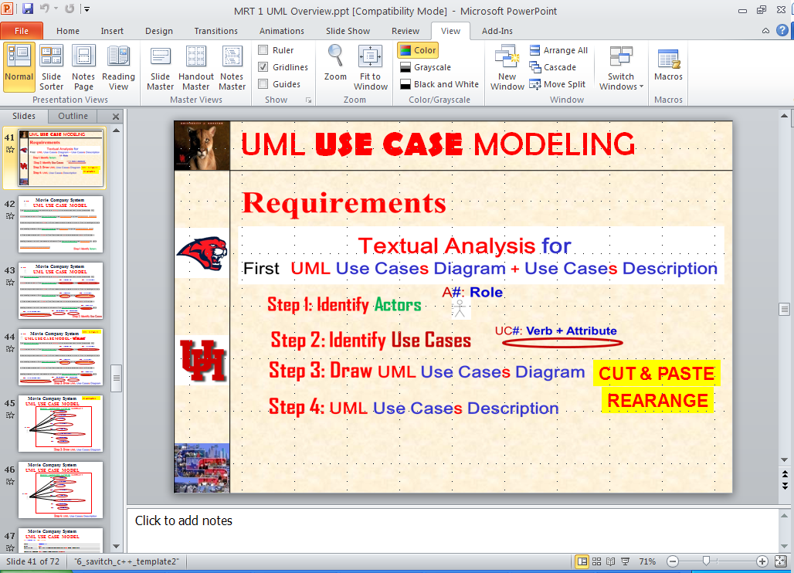

**(Please see the UML Models EXAMPLES on the last pages.**

**DVD Collection Application Requirements:**

**A1: User**

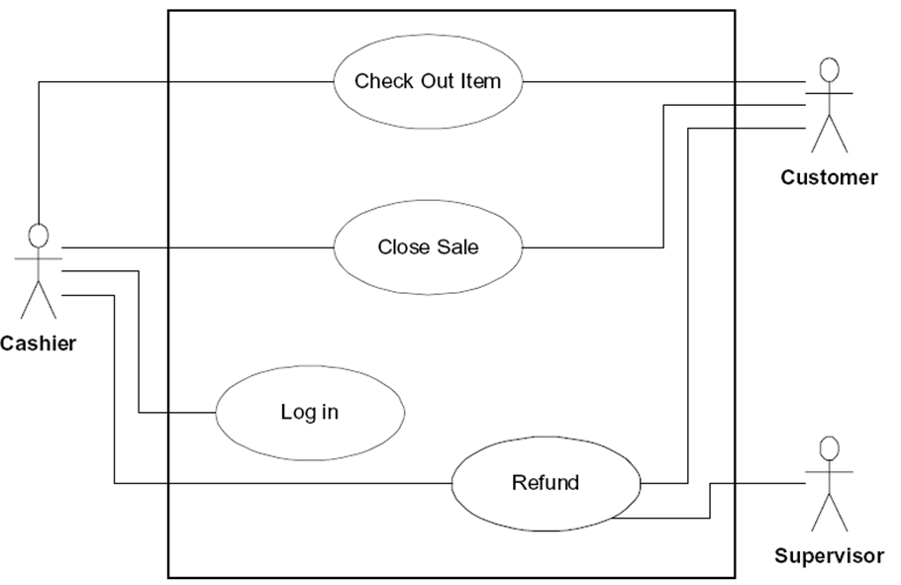

UC1: **UCAddDVD**

**Answer:**

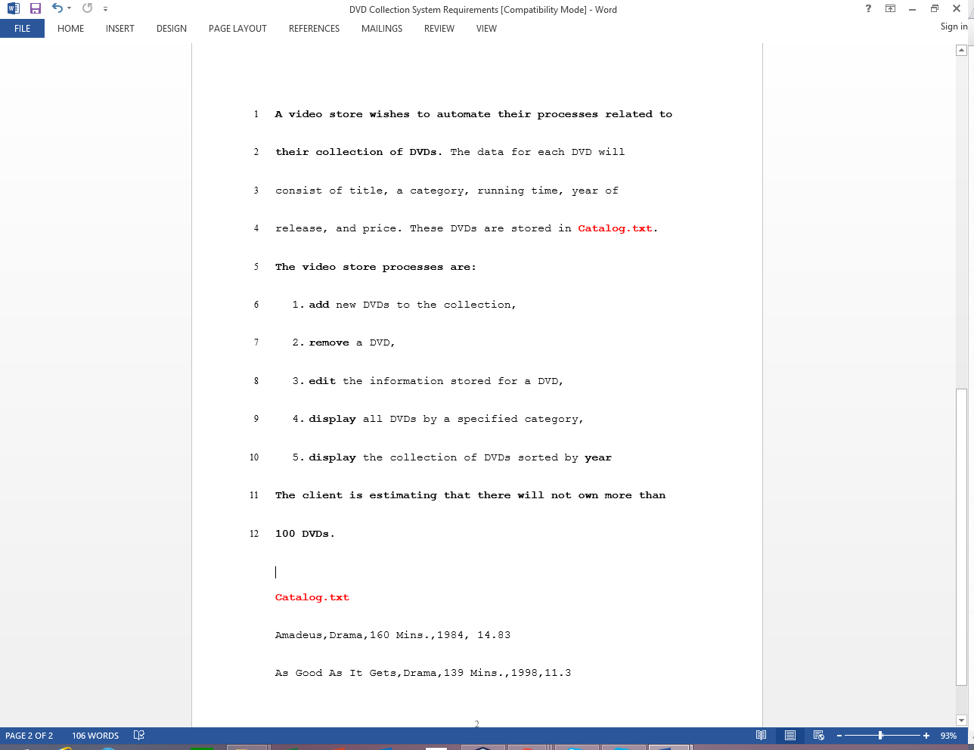

**A1: User**

UC8: UC**SaveCatalog**

UC7: UC**RestoreCatalog**

UC5: **UCDisplayyearDVD**

UC4: **UCDisplaycategoryDVD**

UC3: **UCEditDVD**

UC2: **UCRemoveDVD**

UC1: **UCAddDVD**



**UCAddDVD**

**UCRemoveDVD**

UC**EditDVD**

**Controller**

**UC 1**

**UC2**

**UC3**

**UC4**

**UC5**

**UC6**

**UC7**

**UCDisplaycategoryDVD**

**UCDisplayyearDVD**

UC7: UC**RestoreCatalog**

UC8: UC**SaveCatalog**

A1: **User**



**UC1 UCAddDVD Description**

|  |  |
| --- | --- |
| **Name:** | **UCAddDVD** |
| **Actor:** | **User** |
| **Description:** | **This use case describes the process used by User to Add another DVD** |
| **Successful Completion:** | **User requests Adding DVD by DVDname**   1. **Video store prompts for title, category, running time, year of release, and price** 2. **Video store checks to see if DVD title is already in catalog.txt and it is possible to write into it** 3. **DVD with DVDname is added at the end of catalog.txt and successful message is sent to the User** |
| **Alternative:** | **User requests Adding DVD by DVDname**   1. **Video store checks to see if DVD title is already in catalog.txt and it is possible to write into it** 2. **If DVDname either ALREADY present or it is not possible to write into it, DVDname is NOT added and UNsuccessful message is sent to the User** |
| **Pre-Condition:** | **User requests Add DVD** |
| **Post-Condition:** | **DVD with DVDname Added successfully or UNsuccessfully** |
| **Assumptions:** | **None** |

**UC2 UCRemoveDVD Description**

|  |  |
| --- | --- |
| **Name:** | **UCRemoveDVD** |
| **Actor:** | **User** |
| **Description:** | **This use case describes the process used by User to Remove another DVD** |
| **Successful Completion:** | **User requests Removing DVD by DVDname**   1. **Video store checks to see if DVDname is in catalog.txt** 2. **DVD with DVDname is removed from catalog.txt and successful message is sent to the User** |
| **Alternative:** | **User requests Removing DVD by DVDname**   1. **Video store checks to see if DVDname is in catalog.txt and is not there** 2. **If DVDname is not present DVDname is NOT added and UNsuccessful message is sent to the User** |
| **Pre-Condition:** | **User requests Remove DVD** |
| **Post-Condition:** | **DVD with DVDname remove successfully or UNsuccessfully** |
| **Assumptions:** | **None** |

**UC3 UCEditDVD Description**

|  |  |
| --- | --- |
| **Name:** | **UCEditDVD** |
| **Actor:** | **User** |
| **Description:** | **This use case describes the process used by User to edit a DVD** |
| **Successful Completion:** | **User requests Editing DVD information**   1. **Video store prompts for title, category, running time, year of release, and price** 2. **DVD of title in the catalog.txt is found and category, running time, year of release, and price are changed to new information and successful message is sent to the User** |
| **Alternative:** | 1. **Video store prompts for title, category, running time, year of release, and price** 2. **DVD of title in the catalog.txt is not found and unsuccessful message is sent to the User** |
| **Pre-Condition:** | **User requests Edit DVD** |
| **Post-Condition:** | **DVD of title in the catalog.txt is edited successfully or UNsuccessfully** |
| **Assumptions:** | **None** |

**UC4 UCDisplaycategoryDVD Description**

|  |  |
| --- | --- |
| **Name:** | **UCDisplaycategoryDVD** |
| **Actor:** | **User** |
| **Description:** | **This use case describes the process used by User to display all DVD from a certain category** |
| **Successful Completion:** | **User requests display DVD by category**   1. **Video store displays all the DVD in the catalog.txt by category** |
| **Alternative:** |  |
| **Pre-Condition:** | **User requests display DVD by category** |
| **Post-Condition:** | **DVD of certain category is displayed** |
| **Assumptions:** | **None** |

**UC5 UCDisplayyearDVD Description**

|  |  |
| --- | --- |
| **Name:** | **UCDisplayyearDVD** |
| **Actor:** | **User** |
| **Description:** | **This use case describes the process used by User to display all DVD from a certain year** |
| **Successful Completion:** | **User requests display DVD by category**   1. **Video store displays all the DVD in the catalog.txt by year** |
| **Alternative:** |  |
| **Pre-Condition:** | **User requests display DVD by year** |
| **Post-Condition:** | **DVD of certain year is displayed** |
| **Assumptions:** | **None** |

**UC7 UCRestoreCatalog Description**

|  |  |
| --- | --- |
| **Name:** | **UCRestoreCatalog** |
| **Actor:** | **None** |
| **Description:** | **This use case describes the process of reading the catalog from a data file (Input). It is called automatically when the Video Sotre starts running** |
| **Successful Completion:** | 1. **Opens “Catalog.txt” file and reads the catalog** |
| **Alternative:** |  |
| **Pre-Condition:** | **None** |
| **Post-Condition:** | **The catalog resides in the Video Store memory.** |
| **Assumptions:** | **File “Catalog.txt” was read successfully** |

**UC8 UCSaveCatalog Description**

|  |  |
| --- | --- |
| **Name:** | **UCSaveCatalog** |
| **Actor:** | **None** |
| **Description:** | **This use case describes the process of writing the catalog from Video Store memory to data file “Catalog.txt” (Output). It is called automatically before the Video Store exits** |
| **Successful Completion:** | 1. **Opens “Catalog.txt” file and write the catalog** |
| **Alternative:** |  |
| **Pre-Condition:** | **The catalog resides in the Video Store memory.** |
| **Post-Condition:** | **The catalog resides in the “Catalog.txt” file.** |
| **Assumptions:** | **File “Catalog.txt” was opened for write successfully** |

**UML MVC CLASS Modeling**

2. (50 points)

**Perform “compilable” Textual Analysis with 3 steps (1, 2, and 4) for ANALYSIS Workflows UML MVC CLASS DIAGRAM MODEL (you must use MVC design pattern).**

**(You do not need to show the methods).**

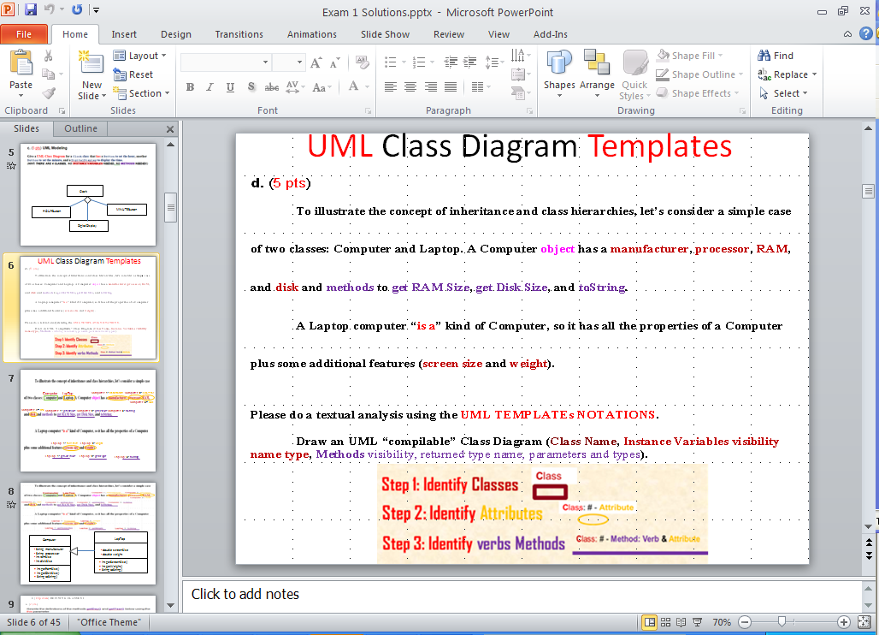

**Please see the UML Models EXAMPLES on the last pages.**

**Artist 1: name : String**

**Catalog**

**Controller 1: UCAddArtist(**String artist**);**

**Catalog 1: addArtist(**String artist**);**

|  |
| --- |
| **Controller** |
| - **catalog**: **Catalog** |
| + **UCAddArtist**(String artist): void // UC1  + **UCListArtists**(): void // UC2  + **UCAddDisc**(String artistName, String discCatalogNumber, String discTitle): void // UC3  + **UCListDiscs**(): void // UC4  + **UCAddTrack**(String discCatalogNumber, String trackTitle, double time): void // UC5  + **UClistTracksForDisc**(String discCatalogNumber): void // UC6  + **UCrestoreCatalog**(): void // UC7  + **UCsaveCatalog**(): void // UC8 |

**DVD Collection Application Requirements:**



**Answer:**

**Catalog 1: numberOfDVDs : Int**

**Catalog 4: Disc[MAX_DVD] DVD**

**Catalog 3: MAX_DVD = 100**

Controller 7: UCRestoreCatalog() void;

Catalog 7: restoreCatalog() void;

Controller 8: UCSaveCatalog() void;

Catalog 8: saveCatalog() void;

**Year**

**Category**

**Price**

**Year of release: yearofrelease : int**

**ca**

**Ca**

**Running time: reuntime : int**

**ca**

**Ca**

**Category1: catname : String**

**ca**

**Ca**

**Price: price : double**

**ca**

**Ca**

**Running time**

**Title 1: name : String**

**ca**

**Ca**

**Title**

**ca**

**Ca**

**Catalog**

**A1: User**



UC5: **UCDisplayyearDVD**

UC4: **UCDisplaycategoryDVD**

UC3: **UCEditDVD**

UC2: **UCRemoveDVD**

UC1: **UCAddDVD**



|  |
| --- |
| **View** |
|  |
| + showDVDs( ) : void |

|  |
| --- |
| **Catalog.txt** |
| * **control: Controller** * **view**: **View**   +title **String**  +category **String**  +runningtime **int**  +yearofrelease **int**  +price **double** |
| + main ( ) |

**Example UML USE CASE Model:**

|  |
| --- |
| **Controller** |
| - **catalog**: **Catalog** |
| + **UCAddDVD**(string titleName, string catName, int runtime, yearofrelease, double price): void // UC1  + **UCRemoveDVD** (string titleName): void // UC2  + **UCEditDVD** (string titleName, string catName, int runtime, int yearofrelease, double price): void // UC3  + **UCDisplaycategoryDVD** (string catName): void // UC4  + **UCDisplayyearDVD** (int yearofrelease): void // UC5  + **UCrestoreCatalog**(): void // UC7  + **UCsaveCatalog**(): void // UC8 |

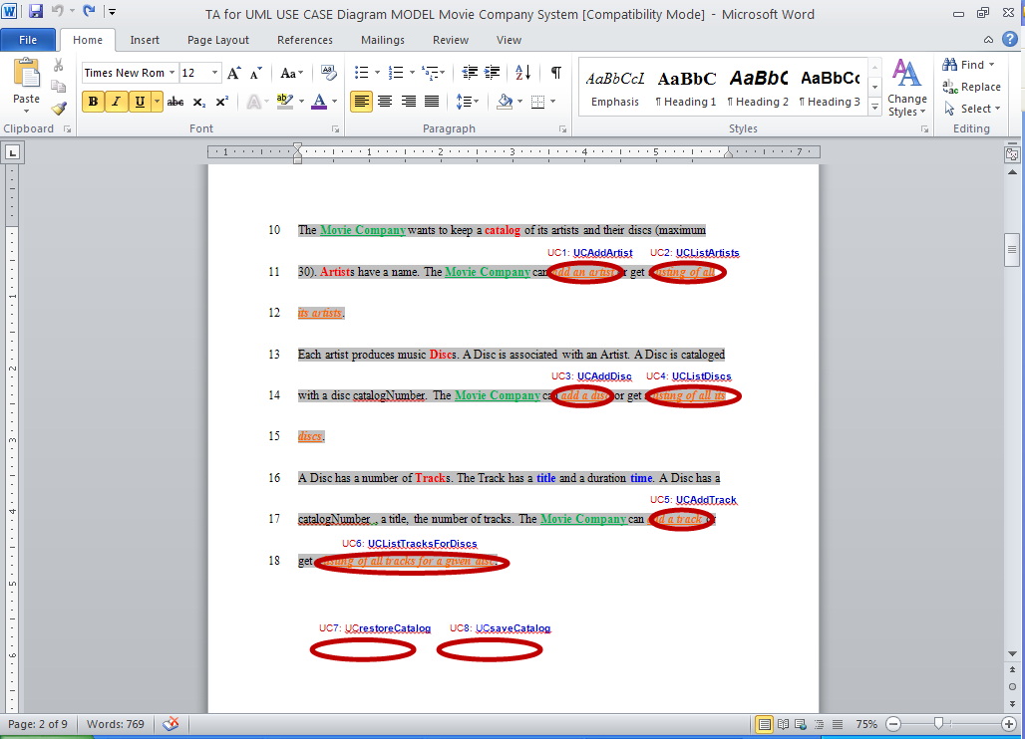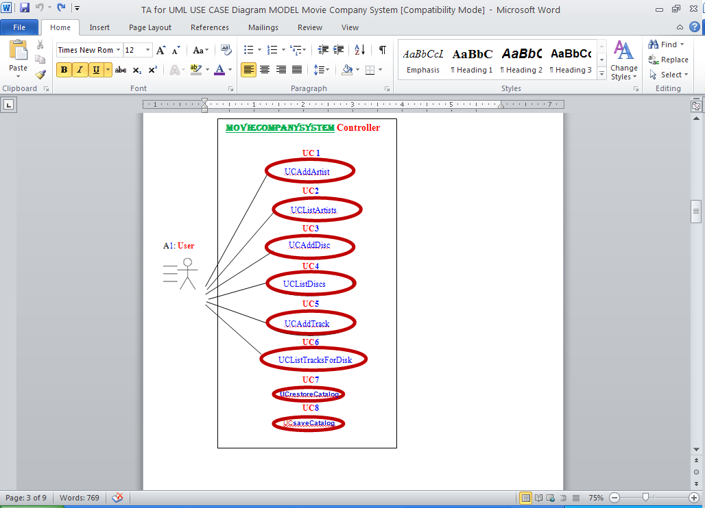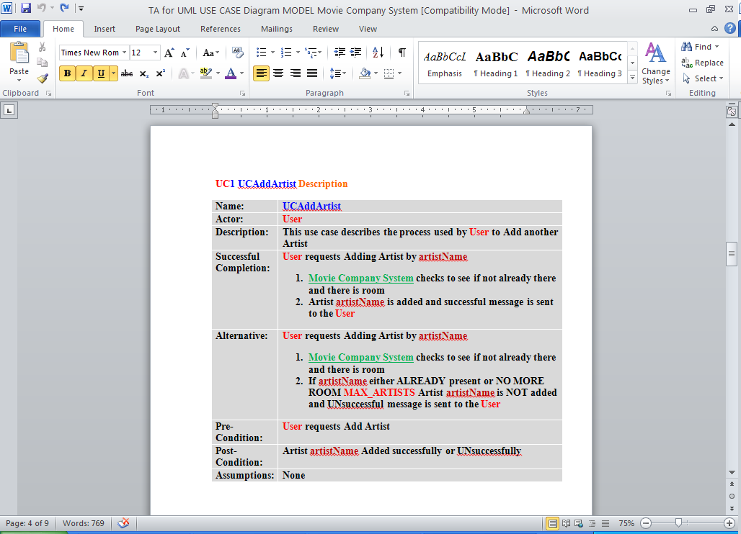

**Example UML MVC CLASS Model:**

